1. **Simulation of single server queue system using GPSS.**
2. **Barber Shop simulation to simulate one day of operation of a barber.**

**Problem:** Customers arrive at barber shop at the rate of 18 ± 6. Mechanic serves each customer at the rate of 16 ± 4 minutes. Simulate system for queue of customer and measure of waiting time for 25 customers.

**Model:**

GENERATE 18,6 ;Customer arrive every 18+/-6 mn

QUEUE Chairs ;Enter the line

SEIZE Joe ;Capture the barber

DEPART Chairs ;Leave the line

ADVANCE 16,4 ;Get a hair cut in 16+/-4 mn

RELEASE Joe ;Free the barber

TERMINATE 1 ;Leave the shop

**Output:**

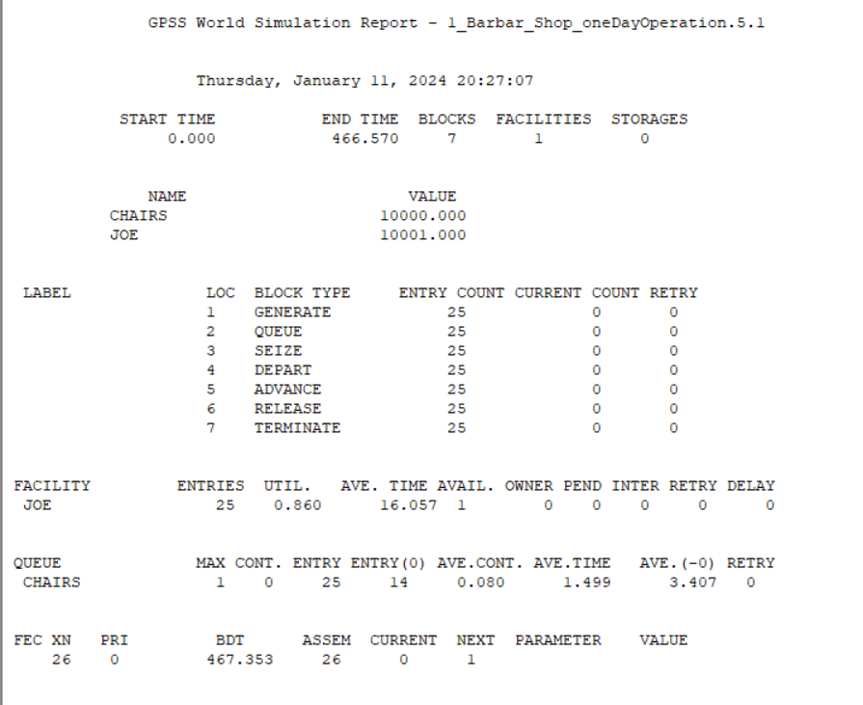

1. **Barber Shop simulation (simple).**

**Problem:** Customers arrive at barber shop at the rate of 300 ± 100. Mechanic serves each customer at the rate of 400 ± 200 minutes. Simulate system for queue of customer and measure of waiting time for 1000 customers.

**Model:**

GENERATE 300,100 ;Create next customer

QUEUE Barber ;Begin queue time

SEIZE Barber ;Own or wait for barber

DEPART Barber ;End queue time

ADVANCE 400,200 ;Haircut takes a few minutes

RELEASE Barber ;Haircut done. Give up the barber.

TERMINATE 1 ;Customer leaves

**Output:**

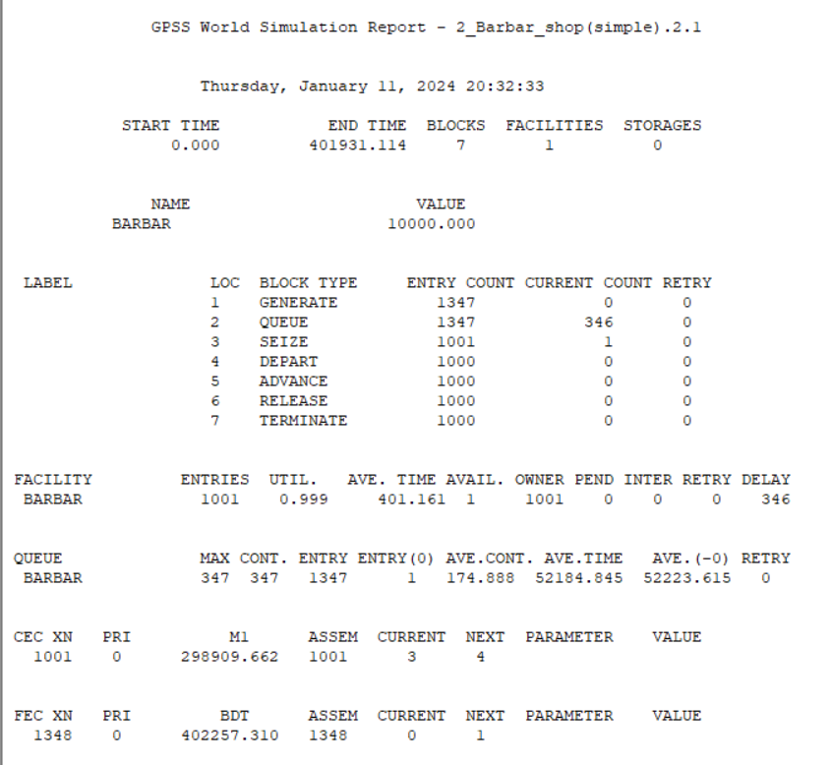

1. **Mechanic Shop simulation.**

**Problem:** Customers arrive at mechanic shop at the rate of 300 ± 200. Mechanic serves each customer at the rate of 200 ± 50 minutes. Simulate system for queue of customer and measure of waiting time for 1000 customers.

**Model:**

GENERATE 300 200 ;create next customer

QUEUE MECHANIC

SEIZE MECHANIC ;Own mechanic(resource)

DEPART MECHANIC

ADVANCE 200 50 ;Mechanic Takes some Time

RELEASE MECHANIC ;Release the resource

TERMINATE 1 ;end simulation

**Output:**

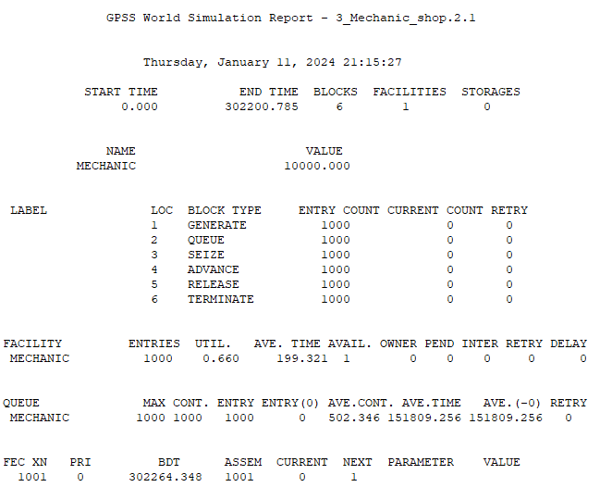

1. **Telephone System Simulation.**

**Problem:** A simple telephone system has two external lines. Calls, which originate externally, arrive every 100±60 seconds. When the line is occupied, the caller redials after 5±1 minutes have elapsed. Call duration is 3±1 minutes. A tabulation of the distribution of the time each caller takes to make a successful call is required. How long will it take for 200 calls to be completed?

**Model:**

Sets STORAGE 2

Transit TABLE M1,.5,1,20 ;Transit times

GENERATE 1.667,1 ;Calls arrive

Again GATE SNF Sets,Occupied ;Try for a line

ENTER Sets ;Connect call

ADVANCE 3,1 ;Speak for 3+/-1 min

LEAVE Sets ;Free a line

TABULATE Transit ;Tabulate transit time

TERMINATE 1 ;Remove a transaction

Occupied ADVANCE 5,1 ;Wait 5 minutes

TRANSFER ,Again ;Try again

**Output:**

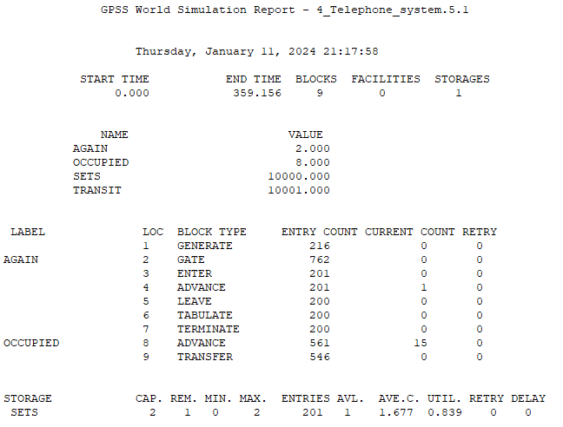

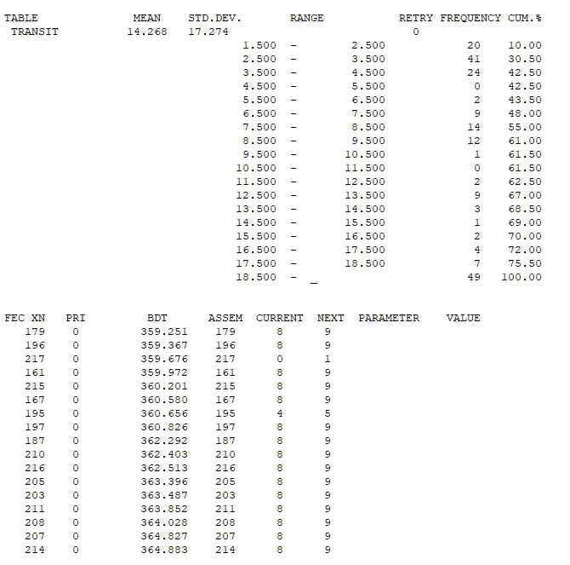

1. **Turnstile of Football Stadium.**

**Problem:** Spectators arrive at a turnstile of a football stadium every 7±7 seconds and queue for admittance. The time to pass through is evenly distributed at 5±3 seconds. A model is required to determine the time taken by 300 people to pass through the turnstile.

**Model:**

In_use EQU 5 ;Mean time

Range EQU 3 ;Half range

GENERATE 7,7 ;People arrive

QUEUE Turn ;Enter queue

SEIZE Turn ;Acquire turnstile

DEPART Turn ;Depart the queue

ADVANCE In_use,Range ;Use turnstile

RELEASE Turn ;Leave turnstile

TERMINATE 1 ;One spectator enters

**Output:**

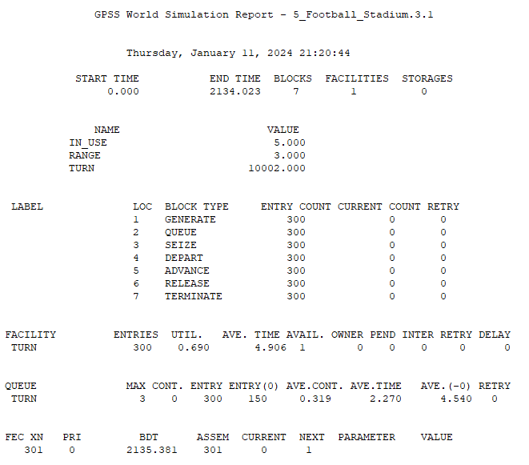

1. **Manufacturing Shop.**

**Problem:** A machine tool in a manufacturing shop is turning out parts at the rate of

every 5 minutes. As they are finished, the parts are turned over to an inspector who takes 4±3 minutes to examine each one and rejects about 10% of the parts as faulty. Each part will be represented by an transaction and the base time unit for the system is chosen as 1 minute. Simulate for 100 parts to leave the system.

**Model:**

GENERATE 5

QUEUE Insq

ENTER Ins,1

DEPART Insq

ADVANCE 4,3

LEAVE Ins,1

TRANSFER 0.1,Acc,Rej

Acc TERMINATE 0

Rej TERMINATE 0

GENERATE 480

TERMINATE 1

Ins STORAGE 3

**Output:**

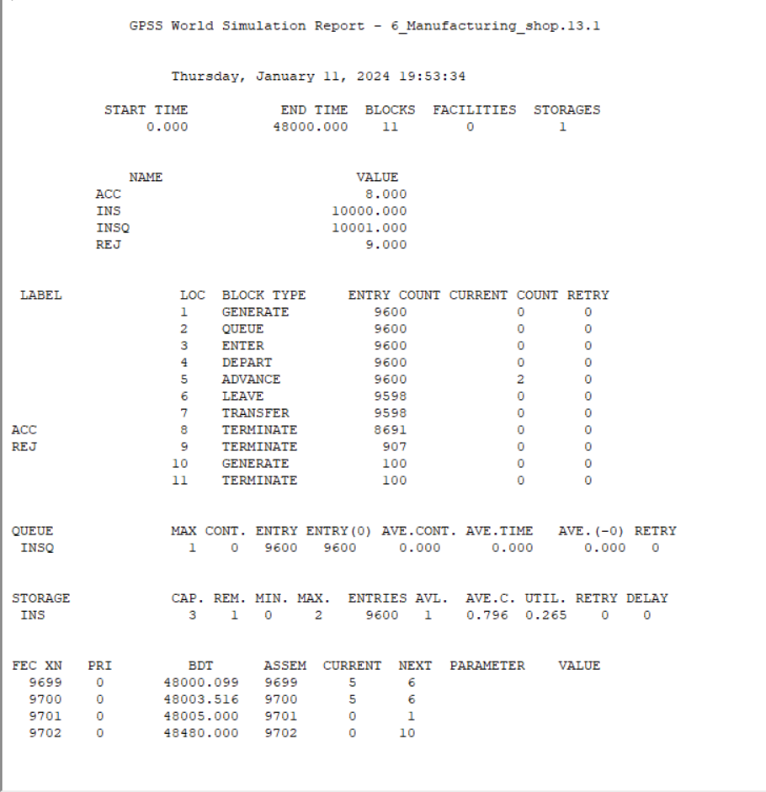

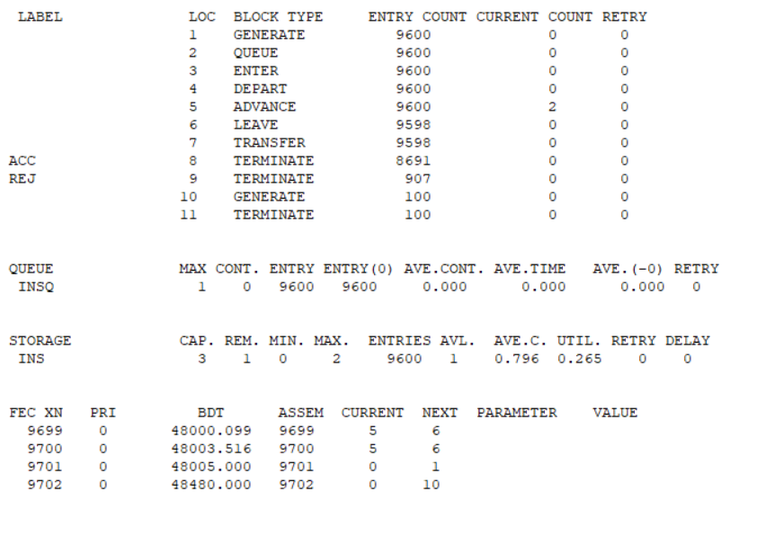

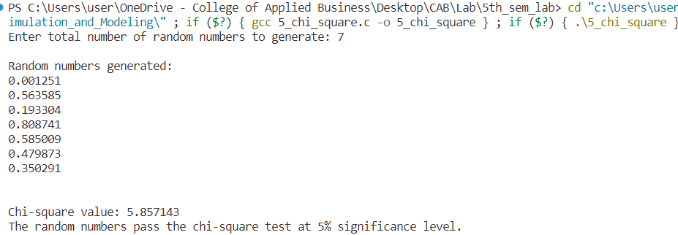

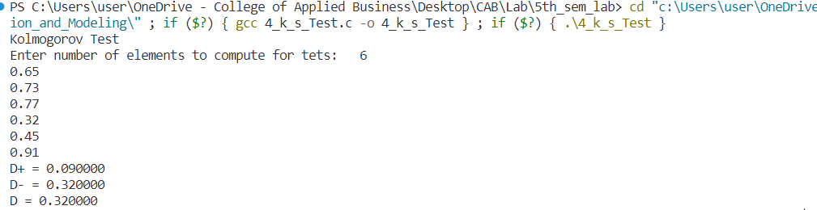

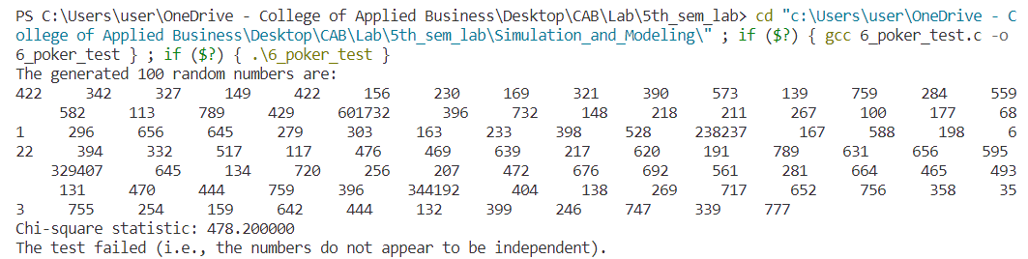

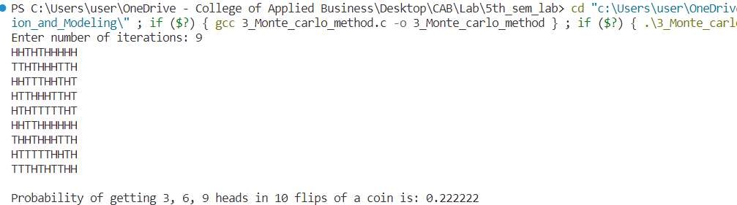

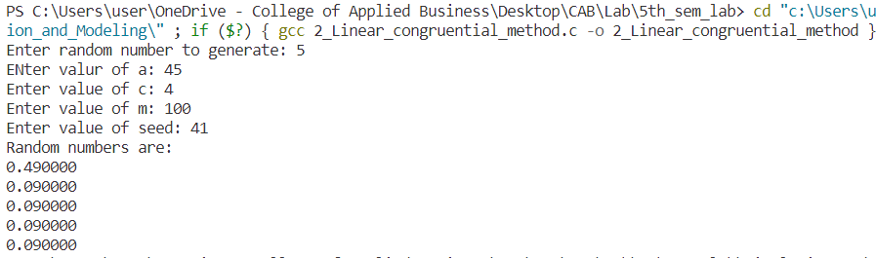

**COLLEGE OF APPLIED BUSINESS AND TECHNOLOGY**

**Kathmandu, Nepal**

**Laboratory Assignment Log Sheet of B.SC. CSIT 5th Semester**

**Subject: CSC 317:Simulation & Modeling**

|  |  |  |  |  |
| --- | --- | --- | --- | --- |
| **Task No.** | **Title** | | | **Signature** |
| 1. | Implement application of Markov Chain. | | |  |
| 2. | Implement application of Monte Carlo Method | | |  |
| 3. | Testing of Random Numbers | | |  |
| A. | Testing of Uniformity | |  |
| i | Implementation of Kolmogorov-Smirnov Test (K-S Test) |  |
| ii. | Implementation of Chi Square Test. |  |
| B. | Testing of Independence | |  |
| i. | Implementation of Poker Test. |  |
| 4. | Implement Linear Congruential Method for random no. generation | | |  |
| 5. | Simulation of single server queue system using GPSS | | |  |
| i. | Barber Shop simulation to simulate one day of operation of a barber | |  |
| ii. | Barber Shop Simulation (simple) | |  |
| iii. | Mechanic Shop simulation | |  |
| iv. | Telephone System Simulation | |  |
| v. | Turnstile of Football Stadium | |  |
| vi. | Manufacturing Shop | |  |